**FLOOD MONITORING SYSTEM**

**Submitted by**

**NAME: SILAMBARASAN. S**

**NM ID: au411521106052**

**Phase-3 Development Part 1**

**PROJECT: Flood Monitoring**

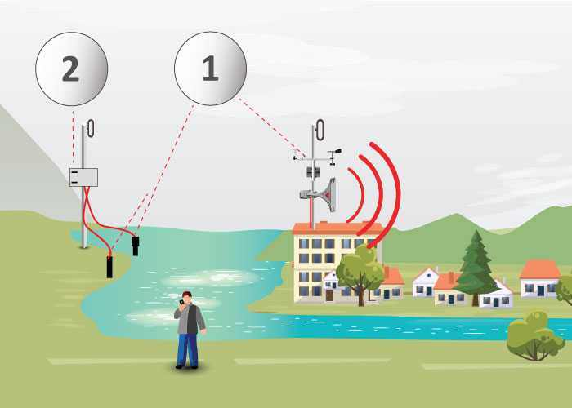

**OBJECTIVE:**

This flood alert system is basically useful to get idea about flood in forecast to do the sensing of the incoming water level for detection of flood is done by implementing sensors. In this way water level will be sensed by the sensor and concerned messages will be given to the controller then it will take the further action on that command.

**INTRODUCTION:**

Flood occurs when water overflows from the river, lake or from heavy rainfall and it can happen at any time of the year. Flooding can be very dangerous, when floods happen in an area that people live, the water carries along objects like houses, cars, furniture and even people.

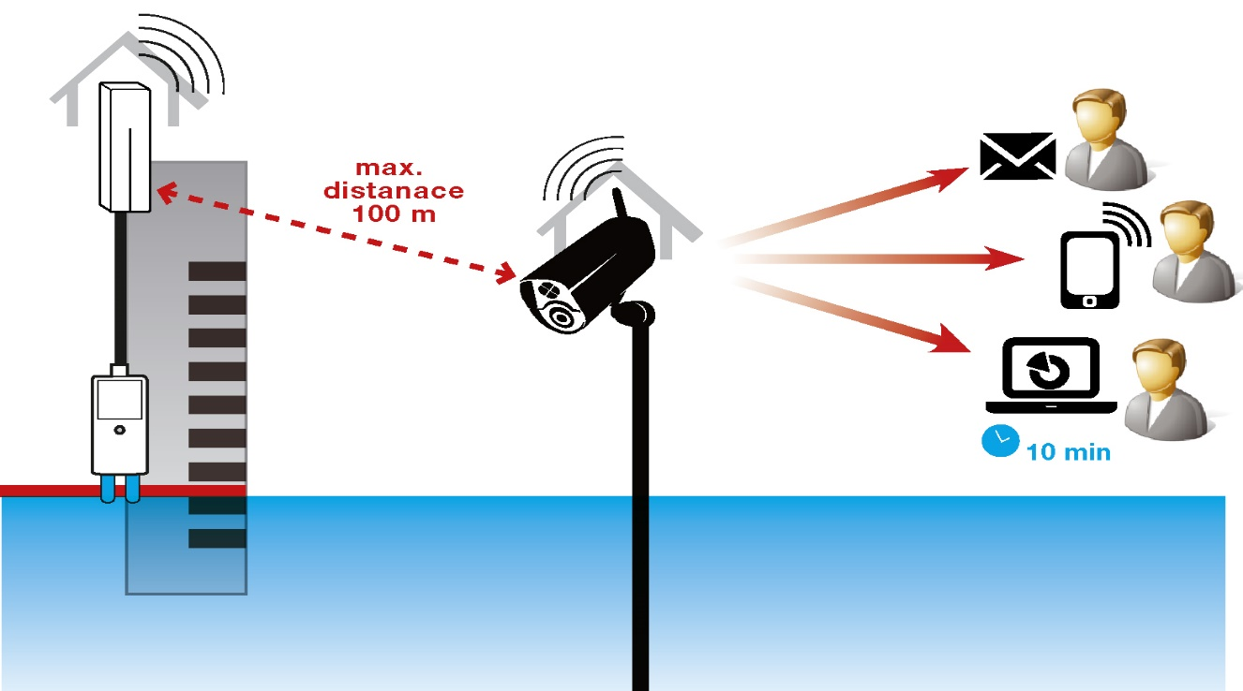

It can wipe away property, trees and many more heavy items. For years, flooded roads have been a problem in Metro Manila. It causes heavy flow of traffic. Both motorists and computers are getting stuck in a flooded areas and getting lost in finding possible routes just to go to their destinations. When traffic happened people’s money, time and effort are wasted. For this reason, the “Arduino Flood Detector System” is been develop, to help the road user to avoid this problem happened. It was invented based on problem faced by motorists and commuters when flood occurred.

**BUILDING AND DEVELOPMENT OF THE PROJECT:**

**COMPONENTS REQUIRED:**

**1.ARDUINO UNO:**

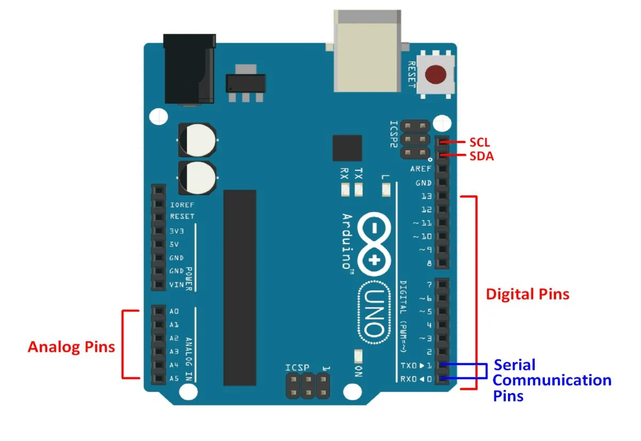

**2.ULTROSONIC SENSOR:**

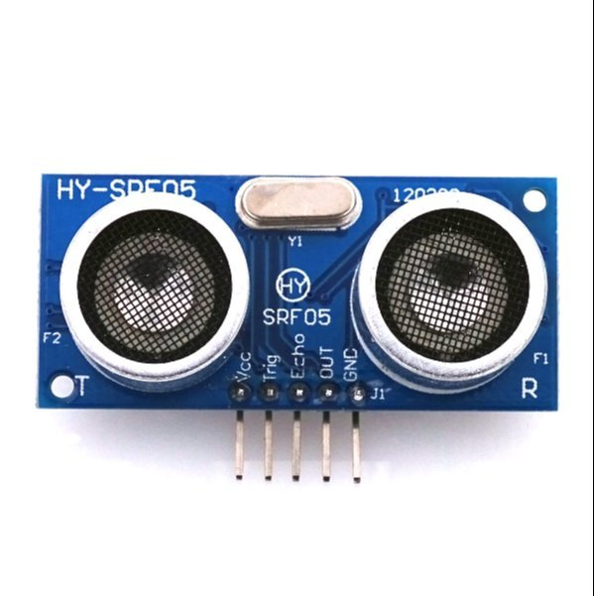

**3.LCD DISPLAY**

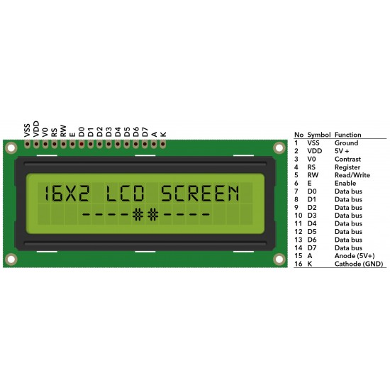

**4.GSMMODULE:**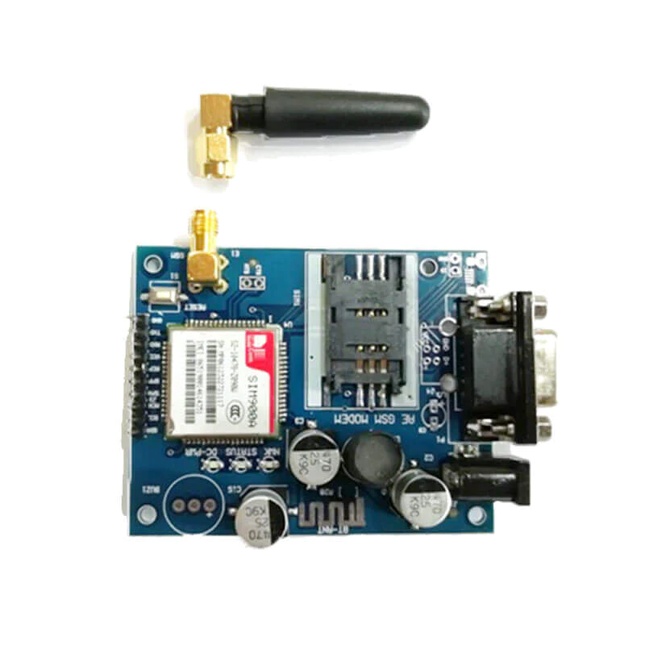

**6.RAIN SENSOR:**

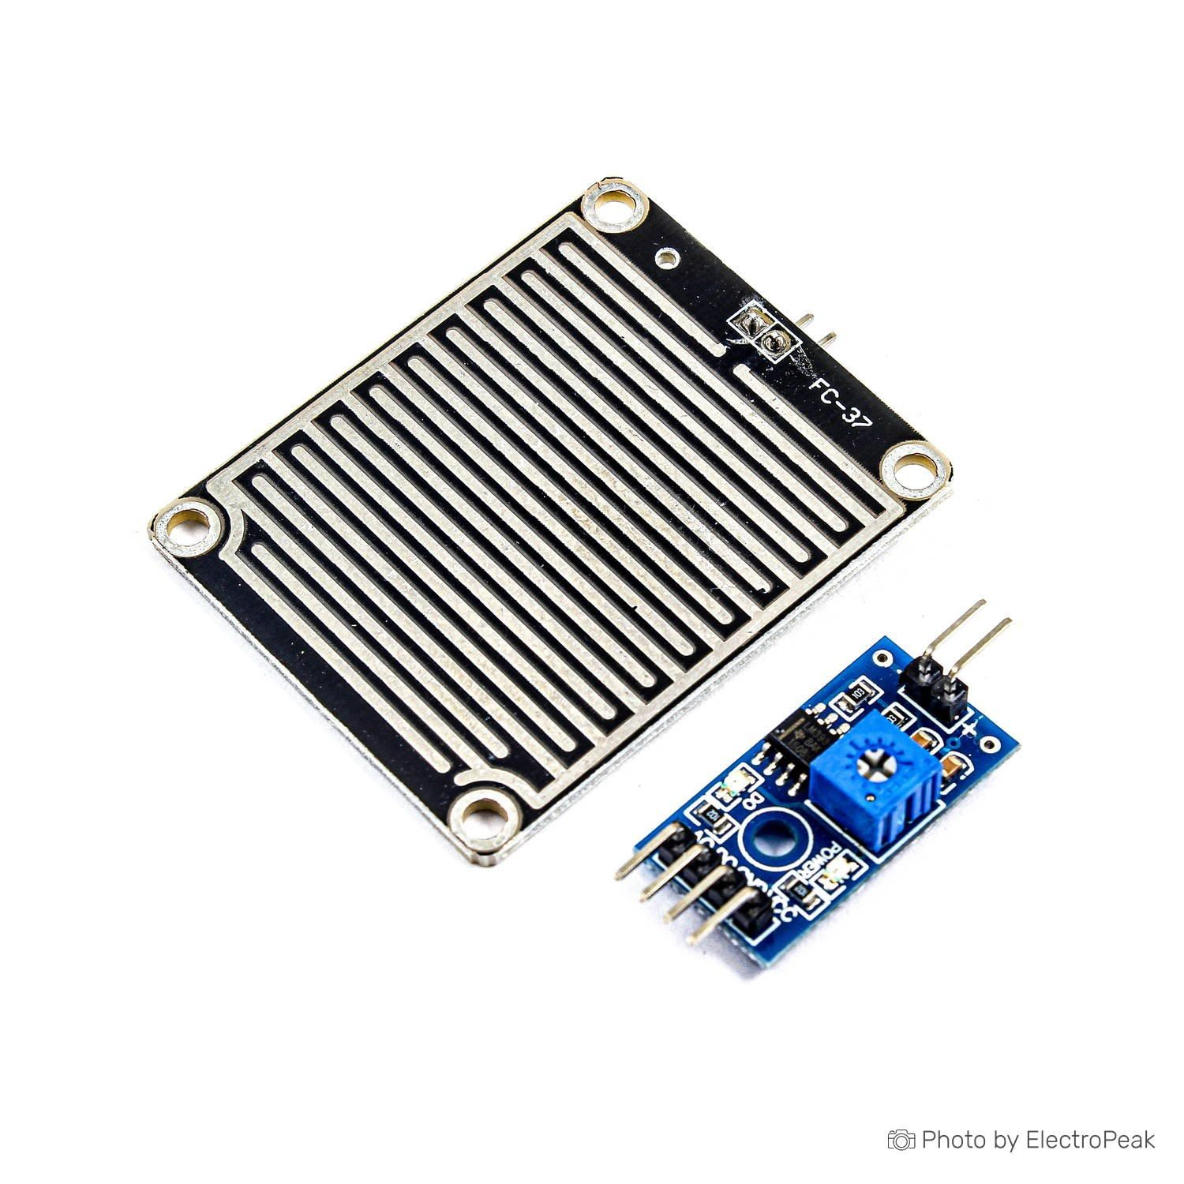

**7.ARDUINO IDE:**

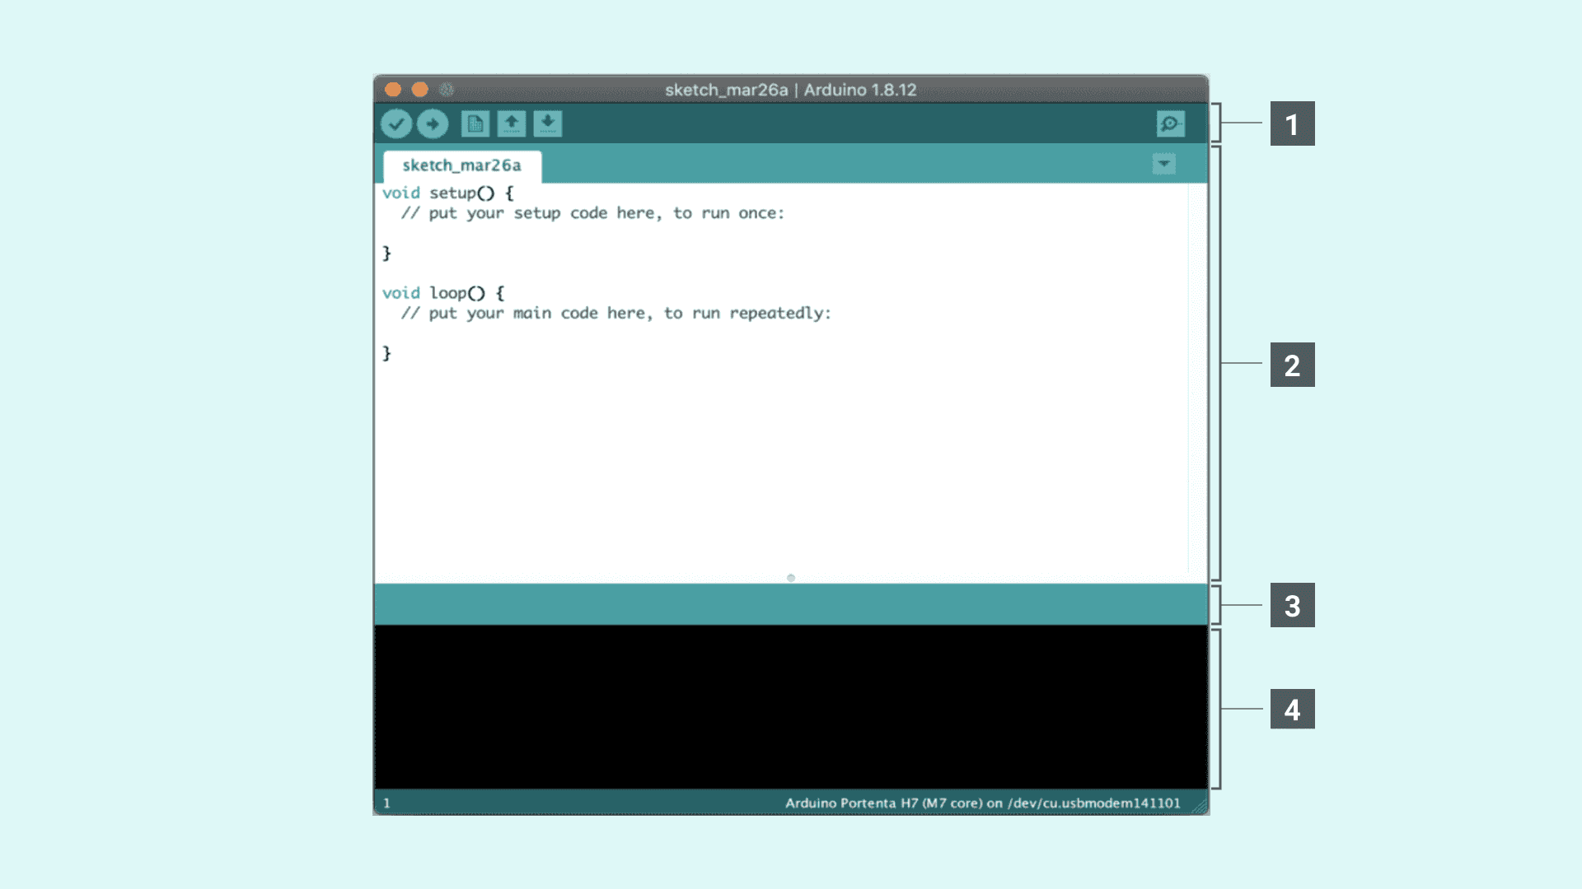

**8.CONNECTING CABLE:**



**9.BLOCK DIAGRAM:**

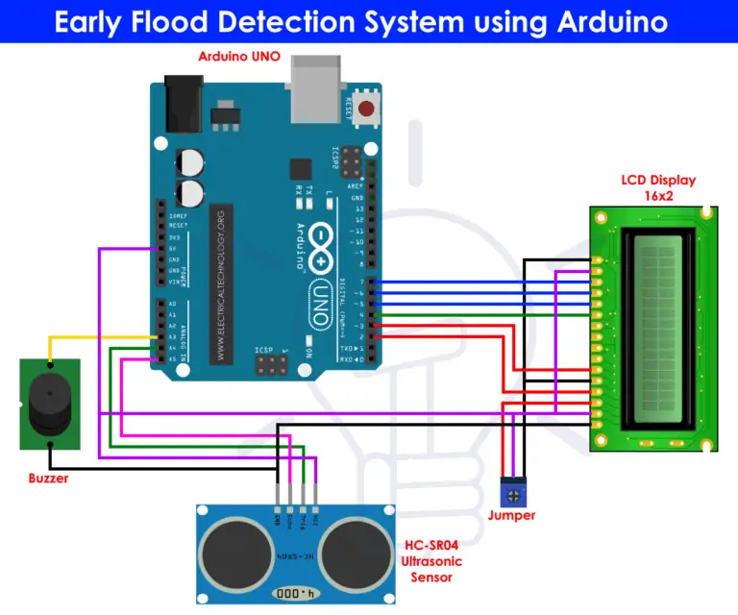

**CONNECTIONS IN ARDUINO:**

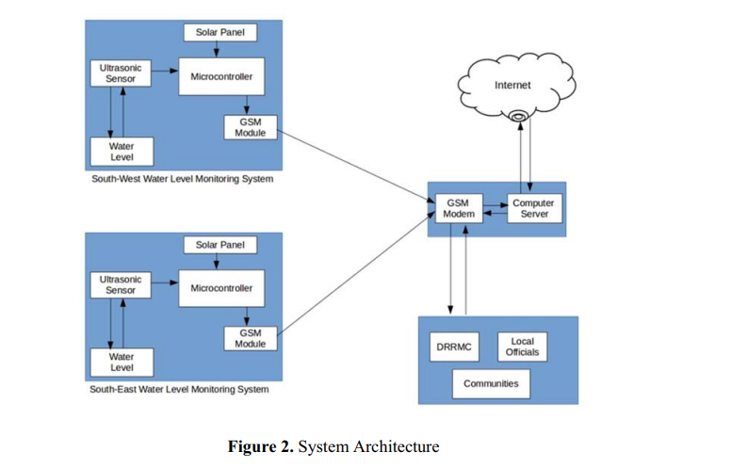

**PROJECT CODE:**

#include

LiquidCrystal lcd(2,3,4,5,6,7);

float t = 0;

float dist = 0;

void setup()

{

lcd.begin(16,2);

pinMode(18,OUTPUT); //trigger pin

pinMode(19,INPUT); //echo pin

pinMode(20,OUTPUT); //buzzer

lcd.setCursor(0,1);

lcd.print(" Water Level Detector");

delay(2000);

}

void loop()

{

lcd.clear();

digitalWrite(20,LOW);

digitalWrite(18,LOW);

delayMicroseconds(2);

digitalWrite(18,HIGH);

delayMicroseconds(10);

digitalWrite(18,LOW);

delayMicroseconds(2);

t=pulseIn(19,HIGH);

dist=t*340/20000;

lcd.clear();

lcd.setCursor(0,1);

lcd.print("Distance : ");

lcd.print(dist/100);

lcd.print(" m");

delay(1000);

if(dist<40)

{

digitalWrite(20,HIGH);

lcd.clear();

lcd.setCursor(0,1);

lcd.print("Water level is rising. Kindly evacuate");

delay(2000);

}

else

{

digitalWrite(20,LOW);

delay(2000);

}

}

**FINAL OUTPUT:**

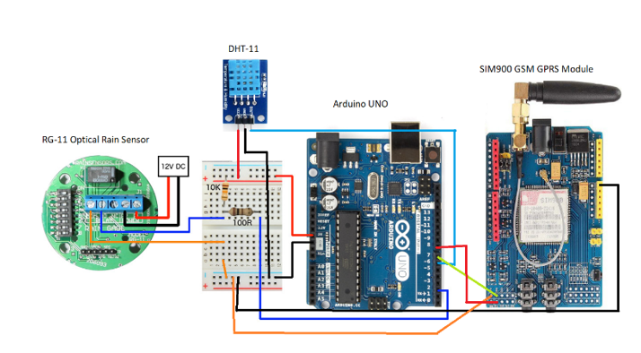

**FINAL PROJECT OUTPUT:**

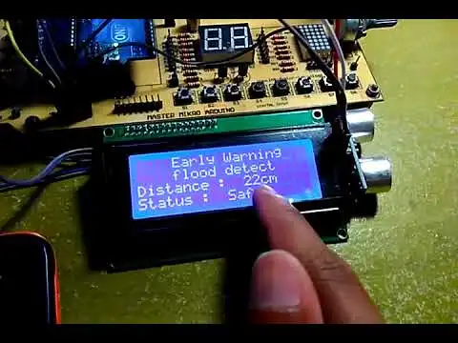

**FUTURE WORK:**

